**Computerarkitektur og -organisering**

*SW-CAO1*

Course Assignment

1

**Authored by:**

Kristian M. P. Dashnaw (344849)

# **Task A:**

*Write down the Arithmetic equation for the logic described in Table 1, and reduce it as much as possible. Put the results in the document.*

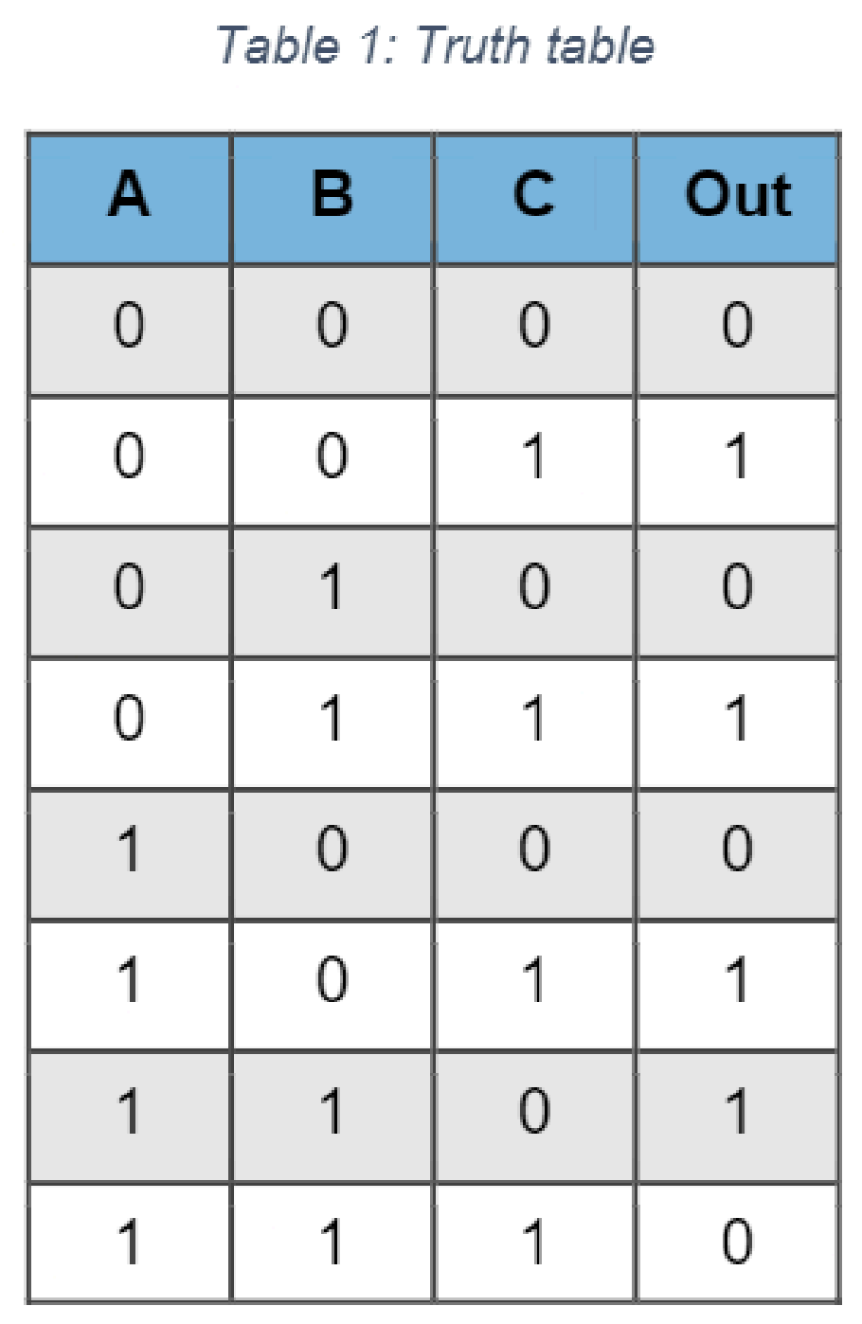

In order to formulate a arithmetic equation for the shown truth table,  
we must first look at all the instances where **Out** results in an output   
of **1**. For each instance of A, B or C on such lines we must either put   
NOT A (if A is 0) and A (if A is 1). Each line is then added to the  
equation through the OR (+) statement.  
  
**From the table we extract this initial equation:**

$\overline{A}\overline{B}C+\overline{A}BC+A\overline{B}C+AB\overline{C}$

**The above can be further reduced:**

$\overline{A}\overline{B}C+\overline{A}BC+A\overline{B}C+AB\overline{C}$

$\overline{A}C(\overline{B}+B)+A\overline{B}C+AB\overline{C}$

$\overline{A}C(1)+A\overline{B}C+AB\overline{C}$

$\overline{A}C+A\overline{B}C+AB\overline{C}$

$C(\overline{A}+A\overline{B})+AB\overline{C}$

$C(\overline{A}+\overline{B})+AB\overline{C}$

$C\overline{B}+C\overline{A}+AB\overline{C}$

# **Task B:**

*Implement the circuit in Logisim using* ***AND****,* ***OR*** *and* ***INVERTER*** *gates. Create a Logisim file called* ***task_b.circ*** *with the designed circuit and insert in the zip file.*

*Please see attached file for Logisim schematic. Above is extracted from that file!*

# **Task C:**

*Write down the Arithmetic equation for the logic described in Table 2 and reduce it as much as possible. Put the result in the document.*

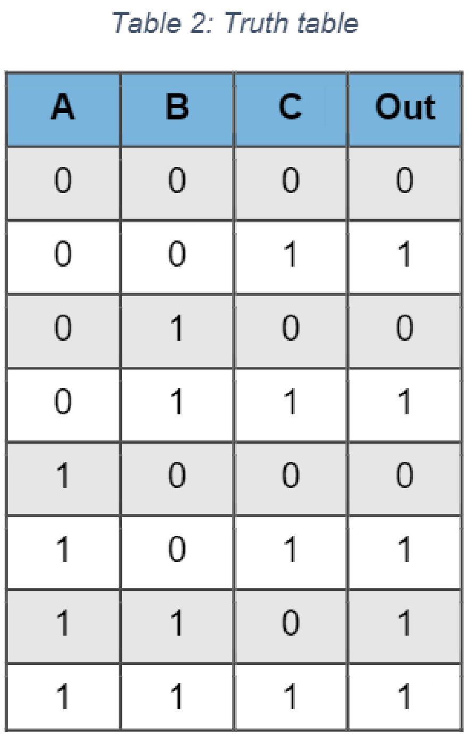

In order to formulate a arithmetic equation for the shown truth table,  
we must first look at all the instances where **Out** results in an output   
of **1**. For each instance of A, B or C on such lines we must either put   
NOT A (if A is 0) and A (if A is 1). Each line is then added to the  
equation through the OR (+) statement.  
  
**From the table we extract this initial equation:**

$\overline{A}\overline{B}C+\overline{A}BC+A\overline{B}C+AB\overline{C}+ABC$

**The above can be further reduced:**

$\overline{A}\overline{B}C+\overline{A}BC+A\overline{B}C+AB\overline{C}+ABC$

$\overline{A}C(\overline{B}+B)+A\overline{B}C+AB(\overline{C}+C)$

$\overline{A}C(1)+A\overline{B}C+AB(1)$

$\overline{A}C+A\overline{B}C+AB$

$\overline{A}C+A(\overline{B}C+B)$

$\overline{A}C+A(C+B)$

$\overline{A}C+AC+AB$

$C(\overline{A}+A)+AB$

$C+AB$

# **Task D:**

*Implement the circuit in Logisim using* ***AND****,* ***OR*** *and* ***INVERTER*** *gates. Create a Logisim file called* ***task_d.circ*** *with the designed circuit and insert in the zip file.*

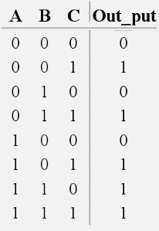

*Please see attached file for Logisim schematic. Above is extracted from that file!*

# **Task E:**

*Draw the output of the DFF in Figure 1 on Figure 2 below and insert the result in the document.*

Based on the principle of Data Flip Flips, where data output can only be changed when write_enable is powered high, the following output can be drawn onto the timing diagram (See **red line**):

**

# **Task F:**

*Explain what happens in each of the instructions above and write down the value of R19 after each of the instructions. Insert the answers in the document.****(Hint if done correctly register 19 (R19) should contain the value 140 in the end)***

|  |  |  |  |
| --- | --- | --- | --- |
| **Address** | **Opcode** | **Hint** | **Explanation** |
| 0 | 1110 0001 0011 1111 | Look at page 129 in the AVR instruction set manual |  |
| 1 | 0110 1100 0011 0100 | Look at page 106 |  |
| 2 | 0111 1010 0011 1100 | Look at page 28 |  |

# **Task G:**

*Fill out the explanations in the table below. If done correctly R18 contains the value 19 in the end.*

|  |  |  |  |
| --- | --- | --- | --- |
| **Address** | **Opcode** | **Hint** | **Explanation** |
| 0 | 1110 1111 0011 1111 | Look at page 129 in the AVR instruction set manual |  |
| 1 | 1110 0001 0110 0100 | Look at page 129 |  |
| 2 | 0000 1111 0010 0110 | Look at page 25 |  |